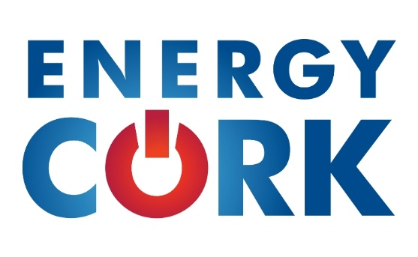

Membership Application
Company/Organisation Name
Address
Telephone
Email
Website
Social Media tags (Twitter/Linkedin)
Number of Employees
Annual Turnover
Number of years in business

Organisation Type (please tick one)
[ ] Start-up  [ ] Sole Trader  [ ] Partnership  [ ] Not-for-profit | [ ] Franchise  [ ] Limited Company  [ ] Co-operative  [ ] Student | [ ] Public Limited Company  [ ] Semi-State Company  [ ] Public Body  [ ] Other (please explain)

Name of Primary Contact
Job Title
Telephone
Email
Alternate Contact (if applicable)
Job Title
Telephone
Email

Industry Sector(s) (please tick up to two)
[ ] Energy supply  [ ] Buildings and Construction | [ ] Demand management  [ ] Climate Action | [ ] Transport  [ ] Other ______________
Business Type(s) (please tick up to three)
[ ] Consultancy  [ ] Research  [ ] Software and IT  [ ] Professional services | [ ] Technology development  [ ] Technology installation  [ ] Technology sales  [ ] Project developer | [ ] Energy production  [ ] Fuel production  [ ] Procurement  [ ] Other ________________

How did you hear about Energy Cork?
How do you think Energy Cork could assist your organisation?

Membership Options and Subscriptions
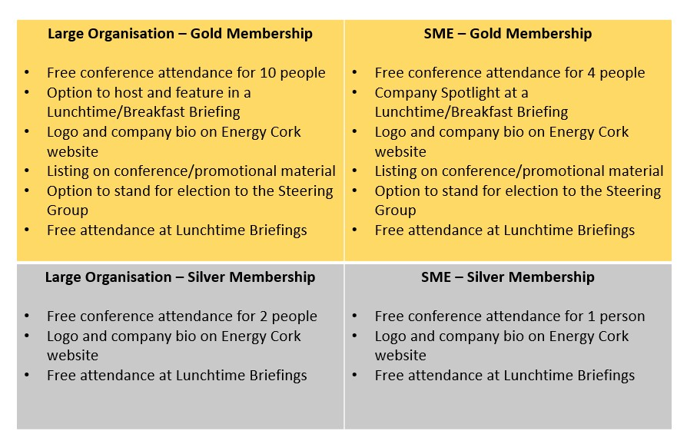
Gold – Large Organisation €2,000 per year – SME €750 per year
Silver – Large Organisation €1,000 per year – SME €500 per year
Energy Cork can facilitate payment via Electronic Funds Transfer and Cheque. Once your application form is accepted and processed, we will contact you regarding subscription fee payment.

Please return completed application forms to:
office@energycork.ie or
Energy Cork, New Civic Offices, Anglesea Street, Cork

